### Scenario 1: qt-restaurant

* QT has an application which is for restaurant order management
* This application has the following architecture and is developed in Java language 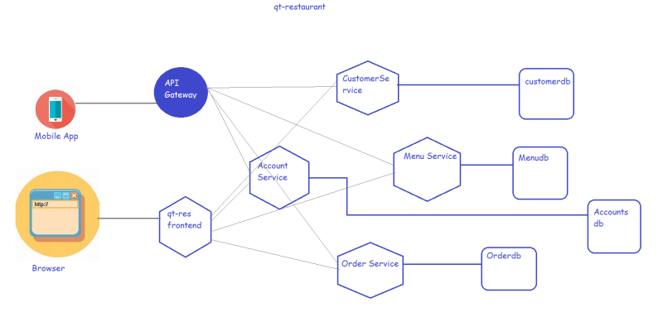
* Each Service and database in this application is running on a different virtual machine
* We need approximately 10 servers to run this app.
* When this application is running
  + can there be server failures?
  + Can there be application failures?
* Can we stop all failures?
* Since we cannot stop all the failures, we can atleast react to failures quickly and resolve.
* For known failures, we need to pro-act and for unknown failures we need to react quickly
* In some cases we can even automate to the error resolution.
* To do all of this we need some kind of system which can monitor
  + server’s health
  + application’s health
  + analyze server logs
  + analyze application logs
  + analyze different metrics from servers and applications
* Building this kind of system can also help in understanding usage patterns of the users which can be analyzed and simplified.
* Generally we have two kinds of monitoring
  + Server Monitoring
  + Application Monitoring
* Whenever any application runs, it generates logs. To understand application behavior we need to analyze logs.
* Analyzing logs is a challenge
  + logs are plain text and are unstructured
  + logs donot have standard format.
* In your organization you might be running multiple applications and having multiple log analysis and monitoring solutions might be challenging, so we need a centralized log monitoring and analysis
* To solve these kind of scenarios there are many centralized log analytics applications, we are going to learn about

Elastic Stack

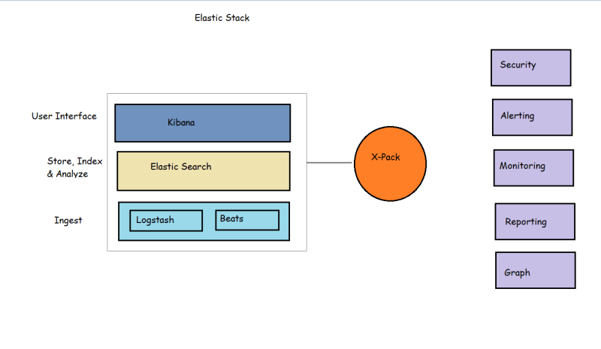

* Logs which are generated by applications or servers are directed into elastic search using logstash or beats.
* Logstash/Beats will forward the logs to elastic search which stores the logs and also has features to analyze the logs
* Kibana which is a UI for elastic search system will help us by providing user interface to
  + create dashboards
  + analyzing the logs

